**Project Description:**

ROV, developed by karylle Ishi Remonde, Christroper Jacob Ong, Sebastian Vidal from team ROV, is a cutting-edge hydration reminder application designed to enhance daily water intake habits. By leveraging GPS technology, ROV provides timely reminders to users based on their location, ensuring they stay hydrated throughout the day. The app features customizable timers and allows users to input the size of their water bottles for accurate tracking. ROV aims to serve a diverse user base, including office professionals, athletes, students, and anyone committed to improving their hydration practices. This app addresses the common challenge of remembering to drink water, promoting better health and wellness through consistent hydration.

**Requirements Summary:**

|  |  |  |  |
| --- | --- | --- | --- |
|  | Processor Cores | Single Core |  |
| **MINIMUM REQUIREMENTS** |  |  |  |
| OS | Android 4.4 (KitKat) |  |
|  |  |
|  |  |  |  |
|  | RAM | 2 GB |  |
|  |  |  |  |
|  | Processor Cores | Quad Core |  |
| **RECOMMENDED REQUIREMENTS** |  |  |  |
| OS | Android 8.0(Oreo) |  |
|  |  |
|  |  |  |  |
|  | RAM | 4 GB |  |
|  |  |  |  |
| **OTHER REQUIREMENTS** | Permissions | Notifications and Storage |  |
|  |  |  |  |

Table 1. System Requirements

To cater to low-end android models, the application will have at most a minimum of 1 Core, 2 GB worth or RAM, and Android version 4.4 or KitKat as its OS. The app itself is not at all demanding, hence our team has settled on lower requirement specs.

Proper hydration is essential for maintaining overall health and well-being, as it supports various bodily functions, including temperature regulation, joint lubrication, and nutrient transportation. Despite its importance, many individuals struggle to consume adequate amounts of water daily. To address this, hydration strategies have been implemented, such as using smartphone apps to track water intake, incorporating hydrating foods like fruits and vegetables into the diet, and promoting the regular consumption of water throughout the day. These approaches aim to ensure that individuals maintain optimal hydration levels, thereby enhancing their physical performance, cognitive function, and overall quality of life. The following sections will explore different hydration techniques, their benefits, and practical tips for achieving proper hydration.

|  |  |
| --- | --- |
| **Technique** | **Description** |
| Hydration Tracking Apps | Hydration tracking apps are tools used to monitor daily water intake. These apps allow users to log their water consumption and set reminders to drink water throughout the day. The app will provide notifications and visual progress indicators to help users stay on track with their hydration goals. This technique is chosen for its convenience and the ability to provide users with real-time feedback on their hydration status. |
|  | Hydration tracking apps are tools used to monitor daily water intake. These apps allow users to log their water consumption and set reminders to drink water throughout the day. The app will provide notifications and visual progress indicators to help users stay on track with their hydration goals. This technique is chosen for its convenience and the ability to provide users with real-time feedback on their hydration status. |
|  | Hydration tracking apps are tools used to monitor daily water intake. These apps allow users to log their water consumption and set reminders to drink water throughout the day. The app will provide notifications and visual progress indicators to help users stay on track with their hydration goals. This technique is chosen for its convenience and the ability to provide users with real-time feedback on their hydration status. |
|  | Hydration tracking apps are tools used to monitor daily water intake. These apps allow users to log their water consumption and set reminders to drink water throughout the day. The app will provide notifications and visual progress indicators to help users stay on track with their hydration goals. This technique is chosen for its convenience and the ability to provide users with real-time feedback on their hydration status. |
|  | Hydration tracking apps are tools used to monitor daily water intake. These apps allow users to log their water consumption and set reminders to drink water throughout the day. The app will provide notifications and visual progress indicators to help users stay on track with their hydration goals. This technique is chosen for its convenience and the ability to provide users with real-time feedback on their hydration status. |
|  |  |
|  |  |
|  |  |
| Hydrating Foods | Incorporating hydrating foods into one's diet is a practical technique for enhancing hydration. Foods such as fruits and vegetables, which have high water content, contribute significantly to daily water intake. This method not only improves hydration but also provides essential vitamins and minerals. It is especially useful for individuals who struggle to drink adequate amounts of water. |
|  |  |
|  |  |
|  |  |
| Regular Water Consumption | Promoting regular water consumption involves encouraging individuals to drink water consistently throughout the day. This can be achieved by setting specific water intake goals, using water bottles with marked measurements, and creating habits such as drinking a glass of water before each meal. This technique ensures steady hydration and helps prevent dehydration, enhancing overall health and cognitive function. |
|  |  |
|  |  |
|  |  |
|  |  |

### Data Presentation and Analysis

**Usability Specifications**

During the online testing with the Participants, Hydration Team ROV observed that the participants interacted effectively with the prototype. Nearly all participants completed each task provided by the team with minimal issues. They were able to quickly learn and memorize the steps and navigation of the prototype, demonstrating ease of use. However, some participants reported minor issues with the responsiveness of certain buttons, likely due to design constraints overlooked during development.

**Table 3. Task Time**

Table 1 shows the results of the timed tasks during the online testing. The data indicates that participants were able to complete each task section in impressive times. Based on these results, the prototype is deemed successful in all three task sections.

**Data Analysis:** The analysis of the task times reveals that participants were able to efficiently navigate and utilize the prototype's functionalities. The Main Menu Task had the quickest completion time, indicating that users found it straightforward to enter and exit the prototype. Both the Folder Task and Quiz Task times were slightly longer but still fell within the highly acceptable range, demonstrating that users were able to perform CRUD (Create, Read, Update, Delete) operations effectively. The minor issues with button responsiveness were noted but did not significantly impede task completion.

**Usability Specifications:** Usability Specifications is the technique used to evaluate the level of usability that the prototype has. It consists of tasks that will be done by participants. Furthermore, the technique involves timing the speed of the participants at a given task. The tasks are divided into three sections: Main Menu Task, Folder Tasks, and Quiz Tasks. This approach is chosen to properly identify any flaws observed when the user interacts with the prototype and to assess how easy it is to use the prototype. The aim is to ensure easy navigation and to allow users to perform CRUD operations efficiently.

**Heuristic Evaluation of ROV Hydration App**

**Visibility of System Status:** ROV effectively informs users about their hydration status through clear indicators and notifications, ensuring users are aware of their current hydration level at all times.

**Match Between System and Real World:** The app uses straightforward language that is easily understandable across all age groups among our participants. This ensures that users can comprehend hydration-related information without difficulty.

**User Control and Freedom:** ROV includes fail-safes such as "Cancel" and "X" buttons to help users recover from accidental actions or navigate back easily. This enhances user control and prevents frustration during app use.

**Consistency and Standards:** While ROV generally maintains consistency in its design, there are occasional issues with the placement and behavior of navigation elements and interactive controls. Addressing these inconsistencies will improve user experience and usability.

**Error Prevention:** ROV implements error prevention measures to minimize user mistakes, although there were some minor issues reported during testing. Improving error prevention strategies will enhance overall user satisfaction and efficiency.

**Recognition Rather Than Recall:** The app provides visible options and actions throughout its interface, ensuring that users do not need to remember information from one screen to another. This supports ease of use and reduces cognitive load.

**Flexibility and Efficiency of Use:** Both novice and experienced users found ROV easy to navigate and use efficiently. The app's intuitive design and clear functionalities contribute to its usability across different user skill levels.

**Aesthetic and Minimalist Design:** ROV features a sleek and minimalist design that aligns with modern usability principles. Unnecessary information is kept to a minimum, focusing on essential hydration-related data and functions.

**Help Users Recognize, Diagnose, and Recover from Errors:** While the app indicates when errors occur, such as tapping on non-interactive elements, it lacks plain language guidance for error recovery. Enhancing error recovery with clearer instructions will improve user satisfaction.

**Help and Documentation:** Users can seek assistance from the support team members available within the app. Providing comprehensive help documentation or tutorials would further support users in utilizing all features effectively.

**Heuristics Conclusion:** Overall, ROV adheres well to most usability heuristics, offering a positive user experience with room for improvement in consistency, error prevention, and error recovery. Participant feedback indicates strong acceptance and success in usability, particularly in navigation and task completion.

**Feedback and Design Implications:** While feedback for ROV was predominantly positive, concerns regarding the difficulty of renaming files and folders were noted. To address this, the team plans to introduce "Pencil" icons for each file and folder, enabling users to easily initiate the renaming process. This enhancement aims to maintain the app's intuitive interface while resolving specific usability issues highlighted by participants.

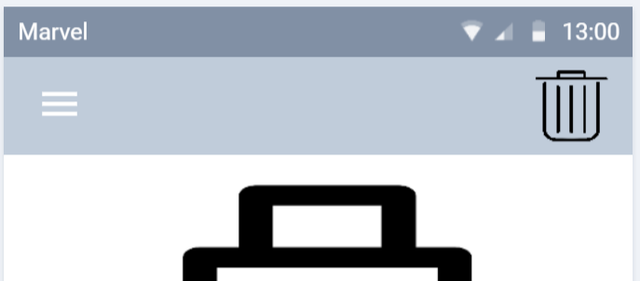

|  |
| --- |
| **Before Alterations** |
|  |  |

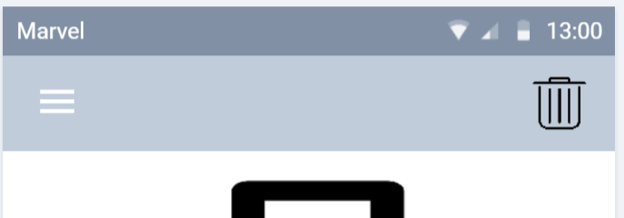

|  |
| --- |
| **After Alterations** |
|  |

Resizing was done to the remove reminder icon to match the task view button on the application.

**Critique and Summary:**

**Advantages and Disadvantages of Evaluation:** The evaluation of the ROV hydration app provided valuable insights and data essential for its development. Conducting the evaluation online facilitated easier participant access and communication via social media platforms, enhancing outreach and efficiency. However, the absence of in-person interactions and laboratory settings limited the depth of data collection. Additionally, challenges such as unreliable internet connectivity in the Philippines posed obstacles, affecting the real-time observation and assessment of participant interactions with the prototype.

**What Could Have Been Done Differently:** In hindsight, conducting separate evaluations for the initial prototype proposal and the revised prototype could have provided more comprehensive feedback for iterative improvements. With increased resources, implementing backend coding would have transformed the prototype into a fully functional application, ready for global distribution on app stores. Enhancing the prototype with features like notifications and online capabilities would have enriched user engagement and utility, addressing some of the limitations observed during evaluation.

**Summary of the Project:** The evaluation focused on benchmark tasks crucial for assessing user interaction with the ROV prototype. Successful aspects included the effective CRUD system and intuitive navigation, highlighting strengths in usability. However, challenges such as the renaming issue and inconsistent navigation detracted from the user experience. Planned features like online capabilities were deferred due to time constraints but would have added significant value. Overall, the project underscored the complexities of prototype design, emphasizing the importance of user-centric design and iterative improvement. Despite challenges, the prototype demonstrated acceptable effectiveness, validating its potential success with users.

**Conclusion:** Designing and evaluating a prototype like ROV entails navigating technical challenges and user expectations. This study illuminated participant proficiency with Android UI, despite their initial exposure to the prototype. Moving forward, the team acknowledges the need for continuous refinement and enhancement, particularly in addressing usability issues and implementing planned features. Ultimately, the ROV hydration app prototype achieved a foundational level of success, setting a promising trajectory for future development and refinement.